Ex: 06 JSON DATA PARSING USING NODE JS & EXPLORATION OF NPM COMMANDS
Date: 19.1.2026
Name: Ajay Kumar S
Roll no: 2024503701
Aim:
To design web server and json data creation and parsing it using Node Js and exploration of npm commands.
Description:
The web server is developed using Node.js to handle client requests and responses efficiently. JSON is used for data storage and exchange, where data is dynamically created and parsed on the server side. Node.js processes the JSON data, extracts required information, and sends structured responses to the client, enabling smooth and organized communication between the server and applications and exporation on npm commands.
Node JS Concepts Used:
- Node.js runtime environment – Executes JavaScript on the server side
- HTTP module – Creates and runs a web server
- Web server creation – Using http.createServer() to handle client requests and responses
- HTTP response handling – Setting headers and sending responses using writeHead() and end()
- Port listening – Running the server on a specified port using server.listen()
- File System (fs) module – Reads external files from the system
- JSON data handling – Reading and processing JSON files
- JSON parsing – Converting JSON content into usable JavaScript objects
- Asynchronous programming – Using callbacks or promises for file reading and data processing
- Error handling – Managing errors during file reading and JSON parsing
Exploration of NPM commands:
- npm init | - Create project + package.json (asks questions)

- npm init –y | - Create project + package.json (default values)

- npm install express | - Install Express package

- npm remove <package> | - Uninstall a package

- npm run <script> | - Run a script from package.json

- npm list | - Show installed packages

- npm start | - Run "start" script

- npm stop | - Run "stop" script

- npm test | - Run "test" script
Code:

Server.js:
const http = require('http');
const fs = require('fs');

const server = http.createServer((req, res) => {
fs.readFile('./data.json', 'utf8', (err, jsonString) => {
if (err) {
res.writeHead(500, {'Content-Type': 'text/plain'});
res.end("Error reading data.json file...");
return;
}
try {
const data = JSON.parse(jsonString);
res.writeHead(200, {'Content-Type': 'application/json'});
res.end(JSON.stringify(data, null, 2));
} catch (err) {
res.writeHead(500, {'Content-Type': 'text/plain'});
res.end("Error parsing JSON data.");
}
});
});
server.listen(3000, () => {
console.log('Server is running at http://localhost:3000');
});
Parse.js:
const fs = require("fs");
const xml2js = require("xml2js");
const parser = new xml2js.Parser();
fs.readFile("students.xml", (err, data) => {
if (err) throw err;
parser.parseString(data, (err, result) => {
if (err) throw err;
console.log(result.students.student);
});
});
Data.json:
{
"hotels": [
{
"hotelId": "H1001",
"name": "Sunrise Grand Hotel",
"location": {
"address": "123 Beach Road",
"city": "Miami",
"country": "USA"
},
"contact": {
"phone": "+1-555-123-4567",
"email": "info@sunrisegrand.com"
},
"rating": 4.5
},
{
"hotelId": "H1002",
"name": "Ocean View Resort",
"location": {
"address": "45 Ocean Drive",
"city": "Los Angeles",
"country": "USA"
},
"contact": {
"phone": "+1-555-234-5678",
"email": "contact@oceanview.com"
},
"rating": 4.2
},
{
"hotelId": "H1003",
"name": "Mountain Stay Inn",
"location": {
"address": "78 Hill Road",
"city": "Denver",
"country": "USA"
},
"contact": {
"phone": "+1-555-345-6789",
"email": "support@mountainstay.com"
},
"rating": 4.0
},
{
"hotelId": "H1004",
"name": "Royal Palace Hotel",
"location": {
"address": "12 King Street",
"city": "London",
"country": "UK"
},
"contact": {
"phone": "+44-555-456-7890",
"email": "info@royalpalace.co.uk"
},
"rating": 4.7
},
{
"hotelId": "H1005",
"name": "City Lights Hotel",
"location": {
"address": "88 Downtown Ave",
"city": "New York",
"country": "USA"
},
"contact": {
"phone": "+1-555-567-8901",
"email": "hello@citylights.com"
},
"rating": 4.3
}
]}
Output:
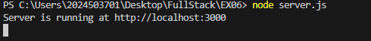
Figure(a) Starting the server
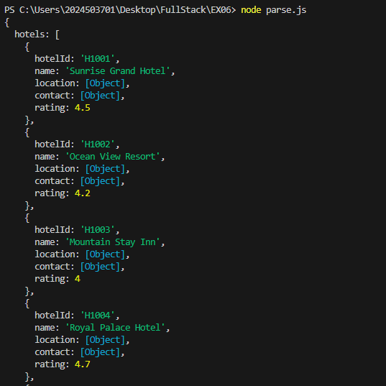
Figure(b)Parsing Console Output

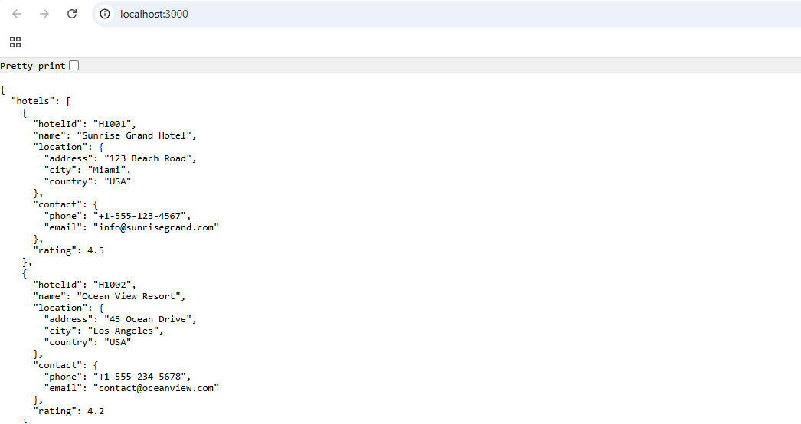
Figure(c)Running in localhost:3000

Exploration on npm commands Output:
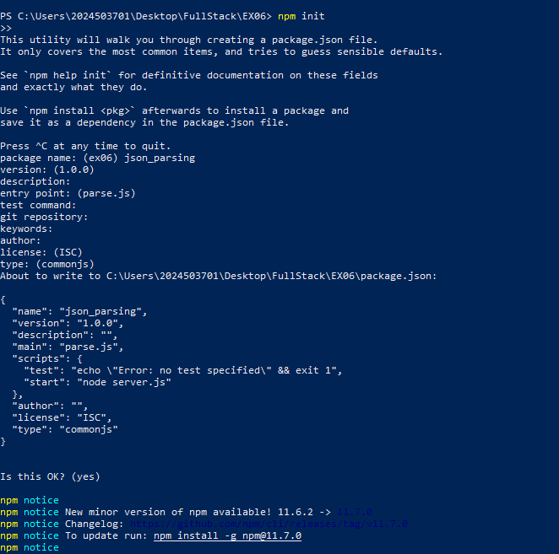
Figure(d)npm init
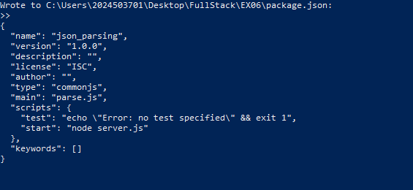
Figure(e)npm init –y
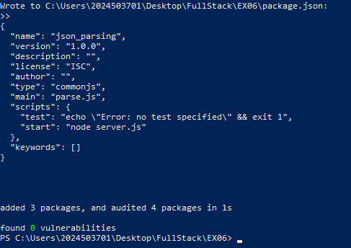
Figure(f)npm install xml2js

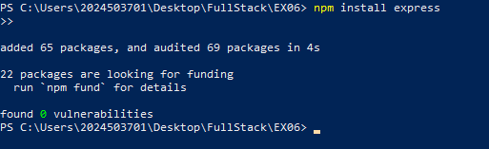
Figure(g)npm install express
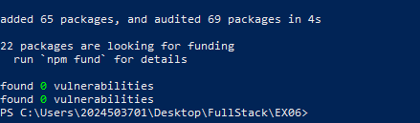
Figure(h)npm audit

Result:
Thus, the web server and JSON data handling system have been implemented successfully, and the output was generated by reading and parsing the JSON file, displaying the student information on the console and server.

